URL for feedback collection

https://erp.hbtu.co.in/feedback.html
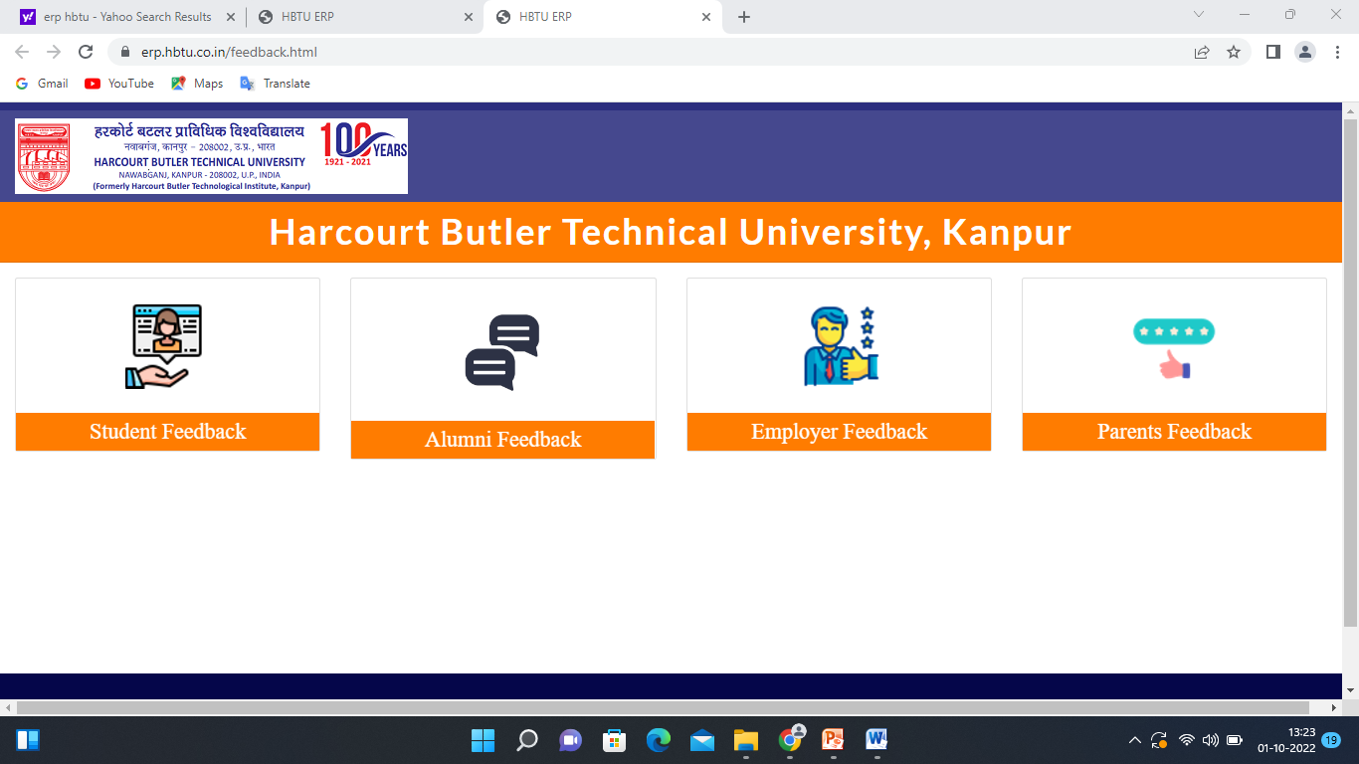

URL for feedback report

http://hbtu.ac.in/naac/criterion1/1.4.2 - Additional Documents.pdf

URL for action taken report

http://hbtu.ac.in/naac/criterion1/1.4.1 - Action Taken Report.pdf

(Anand Kumar)
Dean of Academic Affairs

